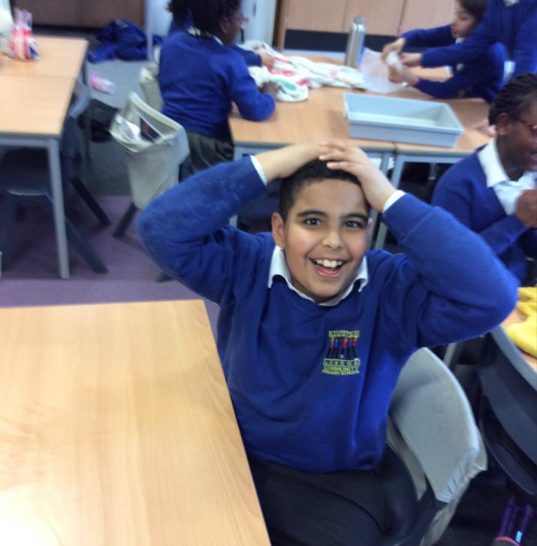

|  |  |
| --- | --- |
| PSHE Subject Handbook | |
|  |  |
| Little London Primary AcademySeptember 2023Joanne Birch |  |

|  |  |  |
| --- | --- | --- |
|  |  |  |
| Introduction |
| At Little London, we strive for our children to be safe, confident, knowledgeable, strong and kind individuals, who are able to make good decisions about their futures and lifestyle choices. Our Personal, Social, Health and Economic wellbeing and careers Education (PSHE) curriculum is a key component in this. We plan and deliver a curriculum which is informative, age-appropriate and vital.  **Vision and Rationale**  At Little London Primary Academy School, we want to ensure our pupils have the knowledge and skills they need to be able to have the chance to grow into happy, safe, successful adults that feel prepared for the realities of modern life. We have ensured that we have planned and built an inclusive curriculum that supports this.  When planning and considering our PSHE curriculum, the voices and needs of our children and community were considered. We include all pupils regardless of their age, sex, race, disability, religion or belief, gender reassignment, or sexual orientation. All classes include pupils with different abilities and aptitudes, experiences, religious/cultural backgrounds, gender and sexual identities. To encourage pupils to participate in lessons, teachers will ensure content, approach and use of inclusive language reflects the diversity of the school community and helps each and every pupil to feel valued and included in the classroom.  As a school, we share our 10 PSHE Ground Rules, which are reflected upon and referred to each lesson and in other areas of the day including other subjects. These Ground Rules cheer and teach sensitivity, understanding, acceptance and respect. Alongside these, we encourage children to use stems sentences that champion privacy, respect and openness, such as ‘Someone I know…’ or ‘I hear what you are saying and I respect that. I think…’  **Implementation**  There are 3 main themes to our PSHE curriculum, these are:   1. Health and Wellbeing 2. Living in the Wider World 3. Relationships   Each half term, children in each year group are presented with a new enquiry based question to start off their topic. Children will complete a self-assessment of ‘Draw and Write’ with all the prior knowledge they have on the area of learning to date. These are then built on each lesson over the course of the topic. Teachers use these to support the direction of learning and content.  Each year group will take on a different PSHE theme each half term, so will cover 6 areas every year. Year 6 will instead go into more depth and have only 3 themes within their year, meaning they have each theme for a full term. Every child will be taught PSHE through our weekly lessons. These are around an hour long. There are the odd topics which will instead be taught as blocks, such as our ‘changes’ puberty topic in Y6. ‘The most effective model of delivery for PSHE is a sequenced, spiral programme that builds on prior learning as pupils progress through school’ with ‘regular curriculum time’ (PSHE Association). Cross curricular links are also made to our PSHE themes, such as the Fairtrade (equalities) geography topic within Year 4.  Learning should be evidence for PSHE in the ‘theme’ workbooks and at least 3 pieces of learning as well as the self-assessments should be evidenced in books. Photographs can be used as evidence of learning.  PSHE themes will also be delivered through whole school or phase assemblies. These will be decided on by the Senior Leadership Team (SLT) and will be part of our ‘responsive curriculum’. We will teach pupils current topics within the media, news and community. Our assemblies will also include a strong emphasis on positive morals, responsibilities and values.  Special days/weeks/months are used to enhance the PSHE curriculum, such as Anti-Bullying week, Black History Month and Endangered Species Day. School songs, including our Leeds one, Proud and It’s the Climb promote our values.  Our very own School Council will meet regularly to discuss how they can promote positive change and will feedback to classes as well as take on the views of their peers. Our strong belief in respectful behaviour reflects our PSHE curriculum. All our staff support upholding this.  As we continue to develop as a school, we aim to offer more workshops and send home more guidance for parents and carers to support them in how to teach topics such as reproduction, online safety, positive image and puberty. Before the more sensitive of PSHE topics, we provide information for parents on the content of our lessons and support to help them teach their child too.  Each class has an ‘Ask-it Basket’, which allows pupils to pop in questions, disclosures or statements, often with reference to our PSHE content. It is important that pupils feel able to ask any questions that they wish and that their questions are valued. While pupils’ questions will be answered as openly and honestly as possible, pupils’ prior learning and readiness must be considered when responding to their questions. Teachers in Little London feel able to ask a pupil to wait for an answer to a challenging question, giving them time to consult with the SLT, the safeguarding team, learning mentors and/or subject leads if they feel this is appropriate, or if the question raises potential safeguarding concerns. (For instance: ‘That is a really interesting question and I need time to think because I want to give you a proper answer.’) Teachers are able to work with colleagues if necessary to construct an appropriate answer. Pupils can also choose whether they would like their question answered in a whole class setting or if they would prefer a private conversation, by indicating on their piece of paper. If a safeguarding issue is raised, school staff will identify the author of the question and process in accordance with the safeguarding policy. Pupils are encouraged to always put their names on the paper.  In certain lessons of the Year 4 and Year 6 puberty topics, children will work in single gender groups. Our policy is sensitive to the needs of different groups. Working in single gender groups can considerably ease concerns about relationships and health education, and help to ensure that pupils receive their curriculum entitlements. Single gender groups can also help boys and girls to feel safer and less embarrassed about airing issues and discussing relationships. Where single gender groups are used for pupils, they will always be given time after the sessions to come together in a controlled environment to share and discuss what they have learnt, before leaving the classroom  Teaching and learning approaches that are considered when delivering PSHE lessons:   * Reflective approach- children are encouraged to we look back on what we know and build on it. * Collaborative approach- children will share and utilise one another and learn from each other’s experiences. * Integrative approach- at times, information becomes cross-curricular. * Enquiry based approach- each topic begins with this and each lesson we revisit it but the direction of learning is still steered by the teacher and the 3 main themes to the PSHE curriculum. * Constructivist approach- children build on experiences and knowledge. They can share and build. Sequenced programmes of learning build on prior knowledge. |  |

**Curriculum Overview**

**Curriculum Overview**

Key Stage 1-2 School Overview

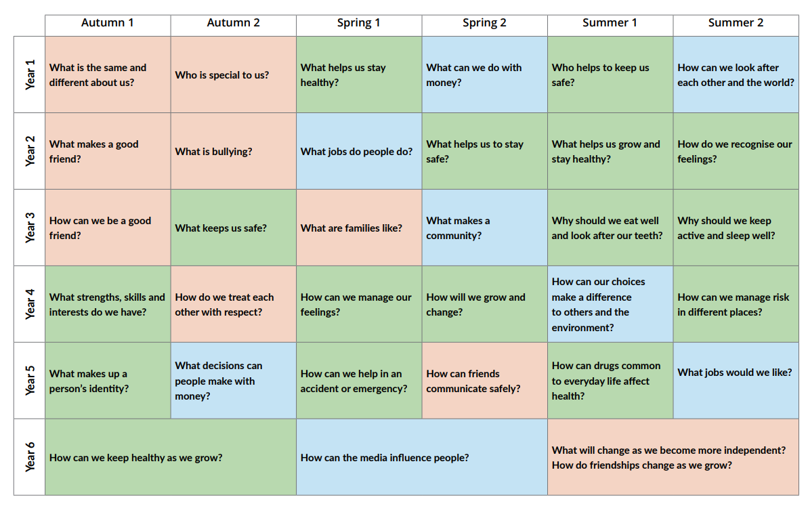

Above shows you the half termly PSHE enquiry based topics taught over the year. Below is a deeper breakdown of this.

Year group overviews

**Reception**

|  |  |  |
| --- | --- | --- |
| **PSHE** | | |
| Reception | PSED | * See themselves as a valuable individual. * Build constructive and respectful relationships. * Express their feelings and consider the feelings of others. * Show resilience and perseverance in the face of challenge. * Identify and moderate their own feelings socially and emotionally. * Think about the perspectives of others. * Manage their own needs: Personal hygiene * Know and talk about the different factors that support their overall health and wellbeing:   • regular physical activity  • healthy eating  • toothbrushing  • sensible amounts of ‘screen time’  • having a good sleep routine  • being a safe pedestrian |
| ELG  (On track – working at ARE) | PSED: Self-regulation, managing self and building relationships | Self-regulation:   * Show an understanding of their own feelings and those of others, and begin to regulate their behaviour accordingly. * Set and work towards simple goals, being able to wait for what they want and control their immediate impulses when appropriate. * Give focused attention to what the teacher says, responding appropriately even when engaged in activity, and show an ability to follow instructions involving several ideas or actions.   Managing self:   * Be confident to try new activities and show independence, resilience and perseverance in the face of challenge. * Explain the reasons for rules, know right from wrong and try to behave accordingly. * Manage their own basic hygiene and personal needs, including dressing, going to the toilet and understanding the importance of healthy food choices.   Building relationships:   * Work and play cooperatively and take turns with others. * Form positive attachments to adults and friendships with peers. * Show sensitivity to their own and to others’ needs. |

Personal, Social and Emotional Development is crucial for children to lead healthy and happy lives, and is fundamental to their cognitive development. Underpinning their personal development are the important attachments that shape their social world. Strong, warm and supportive relationships with adults enable children to learn how to understand their own feelings and those of others. Children should be supported to manage emotions, develop a positive sense of self, set themselves simple goals, have confidence in their own abilities, to persist and wait for what they want and direct attention as necessary. Through adult modelling and guidance, they will learn how to look after their bodies, including healthy eating, and manage personal needs independently. Through supported interaction with other children they learn how to make good friendships, co-operate and resolve conflicts. These attributes will provide a secure platform from which children can achieve at school and in later life.

|  |  |  |  |  |  |  |  |
| --- | --- | --- | --- | --- | --- | --- | --- |
| **Autumn 1**  **All about me and Celebrations** | | | | | | | |
| **PSED**   * See themselves as a valuable individual. * Build constructive and respectful relationships. * Express their feelings and consider the feelings of others. * Show resilience and perseverance in the face of challenge. * Identify and moderate their own feelings socially and emotionally. * Think about the perspectives of others. * Manage their own needs: Personal hygiene * Know and talk about the different factors that support their overall health and wellbeing:   • regular physical activity  • healthy eating  • toothbrushing  • sensible amounts of ‘screen time’  • having a good sleep routine | | | | | | | |
| **PSHE Skills** | | | | | | | |
| Health and Well-being:   * See themselves as a valuable individual- birthday celebration parties. * Manage their own needs. * Express their feelings and those of others. * Show resilience. * Personal hygiene- handwashing before lunch etc. | | | | Living in the Wider World:   * Learning independence and routines. * Think about the perspectives of others. | | | Relationships:   * Talk about family and learn about different types- get to know children and their family, history, culture, likes and dislikes. * Build constructive and respectful relationships- sharing activities and games. |
| *Key texts* | * Goldilocks and the Three Bears * The Colour Monster * Ruby’s Worry * Little Grey’s Birthday Surprise * The Story of Baby Jesus * Family and Me * Rama and Sita | | | | | | |
| **Spring**  **People who help us and Growing** | | | | | | | |
| **PSED**   * Show an understanding of their own feelings and those of others, and begin to regulate their behaviour accordingly. * Set and work towards simple goals, being able to wait for what they want and control their immediate impulses when appropriate. * Give focused attention to what the teacher says, responding appropriately even when engaged in activity, and show an ability to follow instructions involving several ideas or actions. * Be confident to try new activities and show independence, resilience and perseverance in the face of challenge. * Explain the reasons for rules, know right from wrong and try to behave accordingly. * Manage their own basic hygiene and personal needs, including dressing, going to the toilet and understanding the importance of healthy food choices. * Work and play cooperatively and take turns with others. * Form positive attachments to adults and friendships with peers. * Show sensitivity to their own and to others’ needs. | | | | | | | |
| **PSHE Skills** | | | | | | | |
| Health and Well-being:   * Set and work towards simple goals, being able to wait for what they want and control their immediate impulses when appropriate. * Manage their own basic hygiene and personal needs, including dressing, going to the toilet and understanding the importance of healthy food choices- link to Golden Rules and taking care of themselves, school and things. Linked to Oliver’s Vegetables, make a healthy pasta. Link to understanding different cultures and religions- respect. | | | | Living in the Wider World:   * Give focused attention to what the teacher says, responding appropriately even when engaged in activity, and show an ability to follow instructions involving several ideas or actions- food matching game. * Be confident to try new activities and show independence, resilience and perseverance in the face of challenge. * Explain the reasons for rules, know right from wrong and try to behave accordingly. | Relationships:   * Show an understanding of their own feelings and those of others, and begin to regulate their behaviour accordingly- using Stick Man, discuss frustration and how to deal with scenarios. * Work and play cooperatively and take turns with others. * Form positive attachments to adults and friendships with peers. * Show sensitivity to their own and to others’ needs- through story, discuss empathy with things like separation, loss and family. | | |
| *Key texts* | | * Stick Man * Penguins * Dr Ranj’s: A Superhero Like You * The Giant Turnip * Handa’s Surprise * Oliver’s Vegetables | | | | | |
| **Summer**  The Farm and Journeys | | | | | | | |
| **PSED**   * Show an understanding of their own feelings and those of others, and begin to regulate their behaviour accordingly. * Set and work towards simple goals, being able to wait for what they want and control their immediate impulses when appropriate. * Give focused attention to what the teacher says, responding appropriately even when engaged in activity, and show an ability to follow instructions involving several ideas or actions. * Be confident to try new activities and show independence, resilience and perseverance in the face of challenge. * Explain the reasons for rules, know right from wrong and try to behave accordingly. * Manage their own basic hygiene and personal needs, including dressing, going to the toilet and understanding the importance of healthy food choices. * Work and play cooperatively and take turns with others. * Form positive attachments to adults and friendships with peers. * Show sensitivity to their own and to others’ needs. | | | | | | | |
| **PSHE Skills** | | | | | | | |
| Health and Well-being:   * Set and work towards simple goals, being able to wait for what they want and control their immediate impulses when appropriate. * Manage their own basic hygiene and personal needs, including dressing, going to the toilet - health and safety rules travelling to and from school linked to ‘On the Way Home’. | | | | Living in the Wider World:   * Give focused attention to what the teacher says, responding appropriately even when engaged in activity, and show an ability to follow instructions involving several ideas or actions- Y1 transition work. * Be confident to try new activities and show independence, resilience and perseverance in the face of challenge- opportunities for mistakes and show as important part of learning. More independent learning opportunities. * Explain the reasons for rules, know right from wrong and try to behave accordingly. | | | Relationships:   * Show an understanding of their own feelings and those of others, and begin to regulate their behaviour accordingly. * Work and play cooperatively and take turns with others- farm visit providing lots of opportunities for turn taking and team work. * Form positive attachments to adults and friendships with peers. * Show sensitivity to their own and to others’ needs. |
| *Key texts* | | | * How Does an Egg Hatch? * Farmyard Hullabaloo * Farmer Duck * On the Way Home * Rosie’s Walk * We’re Going on a Bear Hunt | | | | |
| **Assessment**  I can develop patience and resilience.  I can understand the needs of others.  I can respect others.  I can keep making steps to becoming more independent.  I can make good, healthy and safe choices.  I can work and play happily with others.  I can solve a problem. | | | | | | | |
| **Vocabulary**  Care, understand, self, family, culture, religion, interests, sleep, healthy, hygiene, respect, relationship, kind, patient, share, listen, support, help, friends, problem, solve, feelings, celebrate, polite, behave, rules, safe, belong, lost, happy, sad, angry, worried, excited, community, independent, achieve, mistake, right, wrong. | | | | | | | |
| **Areas of Continuous Provision**  **Indoors and outdoors**  There are opportunities in all indoor and outdoor provision areas for cooperation, sharing, problem solving, independence, resilience, behaviour reinforcement and acknowledgement and management of feelings.Below are some more specific examples:   * Small world- opportunity for cooperative play and learning about the wider world. * Reading area- books teaching pupils morals, friendships, behaviours and feelings. * Role play- opportunity to role play self-care, empathy for others etc. * Outdoors- turn taking and team work on outdoor vehicles. | | | | | | | |
| **Key Questions – provide opportunities to develop curiosity, where adults can model questions and children can ask questions.** | | | | | | | |
| Health and Well-being  What is the same about us/different about us?  How can you keep your body healthy?  What was the best/worst part of your week?  What things do you do that make you feel happy/sad? | | | | Living in the Wider World  What types of job would you like when you are older? Why?  Do you help with anything at school or home?  What should you do if you don’t do well at something? | | Relationships  How do you feel? How do you think they feel?  Why is it important to share?  What makes a good friend?  Who is special to you and why? | |

**Year 1**

|  |  |  |
| --- | --- | --- |
| **Theme** | **Reference to the statutory content** | **Pupils must learn…** |
| Autumn 1  What is the same and different about us? | Relationships Ourselves and others; similarities and differences; individuality; our bodies | • what they like/dislike and are good at  • what makes them special and how everyone has different strengths  • how their personal features or qualities are unique to them  • how they are similar or different to others, and what they have in common  • to use the correct names for the main parts of the body, including external genitalia; and that parts of bodies covered with underwear are private |
| Autumn 2  Who is special to us? | Relationships Ourselves and others; people who care for us; groups we belong to; families | • that family is one of the groups they belong to, as well as, for example, school, friends, clubs  • about the different people in their family / those that love and care for them  • what their family members, or people that are special to them, do to make them feel loved and cared for  • how families are all different but share common features – what is the same and different about them  • about different features of family life, including what families do / enjoy together  • that it is important to tell someone (such as their teacher) if something about their family makes them feel unhappy or worried |
| Spring 1  What helps us stay healthy? | Health and wellbeing Being healthy; hygiene; medicines; people who help us with health | • what being healthy means and who helps help them to stay healthy (e.g. parent, dentist, doctor)  • that things people put into or onto their bodies can affect how they feel  • how medicines (including vaccinations and immunisations) can help people stay healthy and that some people need to take medicines every day to stay healthy |
| Spring 2  What can we do with money? | Living in the wider world Money; making choices; needs and wants | • what money is - that money comes in different forms  • how money is obtained (e.g. earned, won, borrowed, presents)  • how people make choices about what to do with money, including spending and saving  • the difference between needs and wants - that people may not always be able to have the things they want  • how to keep money safe and the different ways of doing this |
| Summer 1  Who helps to keep us safe? | Health and wellbeing Keeping safe; people who help us | • that people have different roles in the community to help them (and others) keep safe - the jobs they do and how they help people  • who can help them in different places and situations; how to attract someone’s attention or ask for help; what to say  • how to respond safely to adults they don’t know  • what to do if they feel unsafe or worried for themselves or others; and the importance of keeping on asking for support until they are heard  • how to get help if there is an accident and someone is hurt, |
| Summer 2  How can we look after each other and the world? | Living in the wider world Ourselves and others; the world around us; caring for others; growing and changing | • how kind and unkind behaviour can affect others; how to be polite and courteous; how to play and work co-operatively  • the responsibilities they have in and out of the classroom  • how people and animals need to be looked after and cared for  • what can harm the local and global environment; how they and others can help care for it  • how people grow and change and how people’s needs change as they grow from young to old  • how to manage change when moving to a new class/year group |

**Year 2**

|  |  |  |
| --- | --- | --- |
| **Theme** | **Reference to the statutory content** | **Pupils must learn…** |
| Autumn 1  What makes a good friend? | Relationships Friendship; feeling lonely; managing arguments | • how to make friends with others  • how to recognise when they feel lonely and what they could do about it  • how people behave when they are being friendly and what makes a good friend  • how to resolve arguments that can occur in friendships  • how to ask for help if a friendship is making them unhappy |
| Autumn 2  What is bullying? | Relationships Behaviour; bullying; words and actions; respect for others | • how words and actions can affect how people feel  • how to ask for and give/not give permission regarding physical contact and how to respond if physical contact makes them uncomfortable or unsafe  • why name-calling, hurtful teasing, bulling and deliberately excluding others is unacceptable  • how to respond if this happens in different situations  • how to report bullying or other hurtful behaviour, including online, to a trusted adult and the importance of doing so |
| Spring 1  What jobs do people do? | Living in the wider world People and jobs; money; role of the internet | • how jobs help people earn money to pay for things they need and want  • about a range of different jobs, including those done by people they know or people who work in their community  • how people have different strengths and interests that enable them to do different jobs  • how people use the internet and digital devices in their jobs and everyday life |
| Spring 2  What helps us to stay safe? | Health and wellbeing Keeping safe; recognising risk; rules | • how rules and restrictions help them to keep safe (e.g. basic road, fire, cycle, water safety; in relation to medicines/ household products and online)  • how to identify risky and potentially unsafe situations (in familiar and unfamiliar environments, including online) and take steps to avoid or remove themselves from them  • how to resist pressure to do something that makes them feel unsafe or uncomfortable, including keeping secrets  • how not everything they see online is true or trustworthy and that people can pretend to be someone they are not  • how to tell a trusted adult if they are worried for themselves or others, worried that something is unsafe or if they come across something that scares or concerns them |
| Summer 1  What can help us grow and stay healthy? | Health and wellbeing Being healthy: eating, drinking, playing and sleeping | • that different things help their bodies to be healthy, including food and drink, physical activity, sleep and rest  • that eating and drinking too much sugar can affect their health, including dental health  • how to be physically active and how much rest and sleep they should have every day  • that there are different ways to learn and play; how to know when to take a break from screen-time  • how sunshine helps bodies to grow and how to keep safe and well in the sun |
| Summer 2  How do we recognise our feelings? | Health and wellbeing Feelings; mood; times of change; loss and bereavement; growing up | • how to recognise, name and describe a range of feelings  • what helps them to feel good, or better if not feeling good  • how different things / times / experiences can bring about different feelings for different people (including loss, change and bereavement or moving on to a new class/year group)  • how feelings can affect people in their bodies and their behaviour  • ways to manage big feelings and the importance of sharing their feelings with someone they trust  • how to recognise when they might need help with feelings and how to ask for help when they need it |

**Year 3**

|  |  |  |
| --- | --- | --- |
| **Theme** | **Reference to the statutory content** | **Pupils must learn…** |
| Autumn 1  How can we be a good friend? | Relationships Friendship; making positive friendships, managing loneliness, dealing with arguments | • how friendships support wellbeing and the importance of seeking support if feeling lonely or excluded  • how to recognise if others are feeling lonely and excluded and strategies to include them  • how to build good friendships, including identifying qualities that contribute to positive friendships  • that friendships sometimes have difficulties, and how to manage when there is a problem or an argument between friends, resolve disputes and reconcile differences  • how to recognise if a friendship is making them unhappy, feel uncomfortable or unsafe and how to ask for support |
| Autumn 2  What keeps us safe? | Health and wellbeing Keeping safe; at home and school; our bodies; hygiene; medicines and household products | • how to recognise hazards that may cause harm or injury and what they should do to reduce risk and keep themselves (or others) safe  • how to help keep their body protected and safe, e.g. wearing a seatbelt, protective clothing and stabilizers  • that their body belongs to them and should not be hurt or touched without their permission; what to do and who to tell if they feel uncomfortable  • how to recognise and respond to pressure to do something that makes them feel unsafe or uncomfortable (including online)  • how everyday health and hygiene rules and routines help people stay safe and healthy (including how to manage the use of medicines, such as for allergies and asthma, and other household products, responsibly)  • how to react and respond if there is an accident and how to deal with minor injuries e.g. scratches, grazes, burns  • what to do in an emergency, including calling for help and speaking to the emergency services |
| Spring 1  What are families like? | Living in the wider world Community; belonging to groups; similarities and differences; respect for others | • how families differ from each other (including that not every family has the same family structure, e.g. single parents, same sex parents, step-parents, blended families, foster and adoptive parents)  • how common features of positive family life often include shared experiences, e.g. celebrations, special days or holidays  • how people within families should care for each other and the different ways they demonstrate this  • how to ask for help or advice if family relationships are making them feel unhappy, worried or unsafe |
| Spring 2  Why should we eat well and look after our teeth? | Health and wellbeing Being healthy: eating well, dental care | • how to eat a healthy diet and the benefits of nutritionally rich foods  • how to maintain good oral hygiene (including regular brushing and flossing) and the importance of regular visits to the dentist  • how not eating a balanced diet can affect health, including the impact of too much sugar/acidic drinks on dental health  • how people make choices about what to eat and drink, including who or what influences these  • how, when and where to ask for advice and help about healthy eating and dental care |
| Summer 1  Why should we keep active and sleep well? | Health and wellbeing Being healthy: keeping active, taking rest | • how regular physical activity benefits bodies and feelings  • how to be active on a daily and weekly basis - how to balance time online with other activities  • how to make choices about physical activity, including what and who influences decisions  • how the lack of physical activity can affect health and wellbeing  • how lack of sleep can affect the body and mood and simple routines that support good quality sleep  • how to seek support in relation to physical activity, sleep and rest and who to talk to if they are worried |
| Summer 2  What makes a community? | Living in the wider world Community; belonging to groups; similarities and differences; respect for others | • how they belong to different groups and communities, e.g. friendship, faith, clubs, classes/year groups  • what is meant by a diverse community; how different groups make up the wider/local community around the school  • how the community helps everyone to feel included and values the different contributions that people make  • how to be respectful towards people who may live differently to them |

**Year 4**

|  |  |  |
| --- | --- | --- |
| **Theme** | **Reference to the statutory content** | **Pupils must learn…** |
| Autumn 1  What strengths, skills and interests do we have ? | Health and wellbeing Self-esteem: self-worth; personal qualities; goal setting; managing set backs | • how to recognise personal qualities and individuality  • to develop self-worth by identifying positive things about themselves and their achievements  • how their personal attributes, strengths, skills and interests contribute to their self-esteem  • how to set goals for themselves  • how to manage when there are set-backs, learn from mistakes and reframe unhelpful thinking |
| Autumn 2  How do we treat each other with respect? | Relationships Respect for self and others; courteous behaviour; safety; human rights | • how people’s behaviour affects themselves and others, including online  • how to model being polite and courteous in different situations and recognise the respectful behaviour they should receive in return  • about the relationship between rights and responsibilities  • about the right to privacy and how to recognise when a confidence or secret should be kept (such as a nice birthday surprise everyone will find out about) or not agreed to and when to tell (e.g. if someone is being upset or hurt)  • the rights that children have and why it is important to protect these  • that everyone should feel included, respected and not discriminated against; how to respond if they witness or experience exclusion, disrespect or discrimination  • how to respond to aggressive or inappropriate behaviour (including online and unwanted physical contact) – how to report concerns |
| Spring 1  How can we manage our feelings? | Health and wellbeing Feelings and emotions; expression of feelings; behaviour | • how everyday things can affect feelings  • how feelings change over time and can be experienced at different levels of intensity  • the importance of expressing feelings and how they can be expressed in different ways  • how to respond proportionately to, and manage, feelings in different circumstances  • ways of managing feelings at times of loss, grief and change  • how to access advice and support to help manage their own or others’ feelings |
| Spring 2  How will we grow and change? | Health and wellbeing Growing and changing; puberty | • about puberty and how bodies change during puberty, including menstruation and menstrual wellbeing  • how puberty can affect emotions and feelings  • how personal hygiene routines change during puberty  • how to ask for advice and support about growing and changing and puberty |
| Summer 1  How can our choices make a difference to others and the environment? | Living in the wider world Caring for others; the environment; people and animals; shared responsibilities, making choices and decisions | • how people have a shared responsibility to help protect the world around them  • how everyday choices can affect the environment  • how what people choose to buy or spend money on can affect others or the environment (e.g. Fairtrade, single use plastics, giving to charity)  • the skills and vocabulary to share their thoughts, ideas and opinions in discussion about topical issues  • how to show care and concern for others (people and animals)  • how to carry out personal responsibilities in a caring and compassionate way |
| Summer 2  How can we manage risk in different places? | Health and wellbeing Keeping safe; out and about; recognising and managing risk | • how to recognise, predict, assess and manage risk in different situations  • how to keep safe in the local environment and less familiar locations (e.g. near rail, water, road; fire/firework safety; sun safety and the safe use of digital devices when out and about)  • how people can be influenced by their peers’ behaviour and by a desire for peer approval; how to manage this influence  • how people’s online actions can impact on other people  • how to keep safe online, including managing requests for personal information and recognising what is appropriate to share or not share online  • how to report concerns, including about inappropriate online content and contact  • that rules, restrictions and laws exist to help people keep safe and how to respond if they become aware of a situation that is anti-social or against the law |

**Year 5**

|  |  |  |
| --- | --- | --- |
| **Theme** | **Reference to the statutory content** | **Pupils must learn…** |
| Autumn 1  What makes up our identity? | Health and wellbeing Identity; personal attributes and qualities; similarities and differences; individuality; stereotypes | • how to recognise and respect similarities and differences between people and what they have in common with others  • that there are a range of factors that contribute to a person’s identity (e.g. ethnicity, family, faith, culture, gender, hobbies, likes/dislikes)  • how individuality and personal qualities make up someone’s identity (including that gender identity is part of personal identity and for some people does not correspond with their biological sex)  • about stereotypes and how they are not always accurate, and can negatively influence behaviours and attitudes towards others  • how to challenge stereotypes and assumptions about others |
| Autumn 2  What decisions can people make with money? | Living in the wider world Money; making decisions; spending and saving | • how people make decisions about spending and saving money and what influences them  • how to keep track of money so people know how much they have to spend or save  • how people make choices about ways of paying for things they want and need (e.g. from current accounts/savings; store card/ credit cards; loans)  • how to recognise what makes something ‘value for money’ and what this means to them  • that there are risks associated with money (it can be won, lost or stolen) and how money can affect people’s feelings and emotions |
| Spring 1  How can we help in an accident or emergency? | Health and wellbeing Basic first aid, accidents, dealing with emergencies | • how to carry out basic first aid including for burns, scalds, cuts, bleeds, choking, asthma attacks or allergic reactions  • that if someone has experienced a head injury, they should not be moved  • when it is appropriate to use first aid and the importance of seeking adult help  • the importance of remaining calm in an emergency and providing clear information about what has happened to an adult or the emergency services |
| Spring 2  How can friends communicate safely? | Relationships Friendships; relationships; becoming independent; online safety | • about the different types of relationships people have in their lives  • how friends and family communicate together; how the internet and social media can be used positively  • how knowing someone online differs from knowing someone face-to-face  • how to recognise risk in relation to friendships and keeping safe  • about the types of content (including images) that is safe to share online; ways of seeking and giving consent before images or personal information is shared with friends or family  • how to respond if a friendship is making them feel worried, unsafe or uncomfortable  • how to ask for help or advice and respond to pressure, inappropriate contact or concerns about personal safety   * An awareness of FGM, the rights of their own body and where to get support if needed (1 lesson) <https://nationalfgmcentre.org.uk/ks2-lesson-plans/> |
| Summer 1  How can drugs common to everyday life affect health? | Health and wellbeing Drugs, alcohol and tobacco; healthy habits | • how drugs common to everyday life (including smoking/vaping - nicotine, alcohol, caffeine and medicines) can affect health and wellbeing  • that some drugs are legal (but may have laws or restrictions related to them) and other drugs are illegal  • how laws surrounding the use of drugs exist to protect them and others  • why people choose to use or not use different drugs  • how people can prevent or reduce the risks associated with them  • that for some people, drug use can become a habit which is difficult to break  • how organisations help people to stop smoking and the support available to help people if they have concerns about any drug use  • how to ask for help from a trusted adult if they have any worries or concerns about drugs |
| Summer 2  What jobs would we like? | Living in the wider world Careers; aspirations; role models; the future | • that there is a broad range of different jobs and people often have more than one during their careers and over their lifetime  • that some jobs are paid more than others and some may be voluntary (unpaid)  • about the skills, attributes, qualifications and training needed for different jobs  • that there are different ways into jobs and careers, including college, apprenticeships and university  • how people choose a career/job and what influences their decision, including skills, interests and pay  • how to question and challenge stereotypes about the types of jobs people can do  • how they might choose a career/job for themselves when they are older, why they would choose it and what might influence their decisions |

**Year 6**

* Year 6 includes some non-statutory content related to Sex Education. The non-statutory learning is highlighted in yellow.

|  |  |  |
| --- | --- | --- |
| **Theme** | **Reference to the statutory content** | **Pupils must learn…** |
| Autumn 1 & 2  How can we keep healthy as we grow? | Health and wellbeing Looking after ourselves; growing up; becoming independent; taking more responsibility | • how mental and physical health are linked  • how positive friendships and being involved in activities such as clubs and community groups support wellbeing  • how to make choices that support a healthy, balanced lifestyle including: » how to plan a healthy meal » how to stay physically active » how to maintain good dental health, including oral hygiene, food and drink choices » how to benefit from and stay safe in the sun » how and why to balance time spent online with other activities » how sleep contributes to a healthy lifestyle; the effects of poor sleep; strategies that support good quality sleep » how to manage the influence of friends and family on health choices  • that habits can be healthy or unhealthy; strategies to help change or break an unhealthy habit or take up a new healthy one  • how legal and illegal drugs (legal and illegal) can affect health and how to manage situations involving them  • how to recognise early signs of physical or mental ill-health and what to do about this, including whom to speak to in and outside school  • that health problems, including mental health problems, can build up if they are not recognised, managed, or if help is not sought early on  • that anyone can experience mental ill-health and to discuss concerns with a trusted adult  • that mental health difficulties can usually be resolved or managed with the right strategies and support |
| Spring 1 & 2  How can the media influence people? | Living the wider world Media literacy and digital resilience; influences and decision-making; online safety | • how the media, including online experiences, can affect people’s wellbeing – their thoughts, feelings and actions  • that not everything should be shared online or social media and that there are rules about this, including the distribution of images  • that mixed messages in the media exist (including about health, the news and different groups of people) and that these can influence opinions and decisions  • how text and images can be manipulated or invented; strategies to recognise this  • to evaluate how reliable different types of online content and media are, e.g. videos, blogs, news, reviews, adverts  • to recognise unsafe or suspicious content online and what to do about it  • how information is ranked, selected, targeted to meet the interests of individuals and groups, and can be used to influence them  • how to make decisions about the content they view online or in the media and know if it is appropriate for their age range  • how to respond to and if necessary, report information viewed online which is upsetting, frightening or untrue  • to recognise the risks involved in gambling related activities, what might influence somebody to gamble and the impact it might have  • to discuss and debate what influences people’s decisions, taking into consideration different viewpoints |
| Summer 1 & 2  What will change as we become more independent?  How do friendships change as we grow? | Relationships Different relationships, changing and growing, adulthood, independence, moving to secondary school | • that people have different kinds of relationships in their lives, including romantic or intimate relationships  • that people who are attracted to and love each other can be of any gender, ethnicity or faith; the way couples care for one another  • that adults can choose to be part of a committed relationship or not, including marriage or civil partnership  • that marriage should be wanted equally by both people and that forcing someone to marry against their will is a crime  • how puberty relates to growing from childhood to adulthood, including a recap on menstruation and menstrual wellbeing, erections and wet dreams  • about the reproductive organs and process - how babies are conceived and born and how they need to be cared for  • that there are ways to prevent a baby being made  • how growing up and becoming more independent comes with increased opportunities and responsibilities  • how friendships may change as they grow and how to manage this  • how to manage change, including moving to secondary school; how to ask for support or where to seek further information and advice regarding growing up and changing   * July 2024 only for Y6, then Y5 only each year after: An awareness of FGM, the rights of their own body and where to get support if needed (1 lesson) <https://nationalfgmcentre.org.uk/ks2-lesson-plans/> |

*SMSC themes are interwoven through lessons and all curriculum subjects support SMSC with dedicated questioning of SMSC strands through curriculum lessons.*

**Impact**

The impact of the PSHE curriculum on pupils’ outcomes will be measured across a half term. Each lesson, as referred to within the implementation section earlier within this handbook, children will fill in their self-assessment. Below are examples of these and these will be stuck in to their ‘theme’ workbooks. Children will ‘Draw and Write’ what they know in reference to the lesson and enquiry question. Teachers should check and mark these each lesson and provide feedback. If feedback is written, children should always be given the chance at the start of the lesson or the next day to respond and edit using a green pen. If feedback is quite substantive and a crucial teaching point has been missed or misunderstood, teachers should spend some time 1:1 verbally working with the child. The sensitivity of the topic should be considered by the teacher when thinking about how and where to work on this. If teachers note several of the same misconceptions or missed learning, then this should be reflected in their future planning for the whole class. The PSHE leader will monitor this closely.

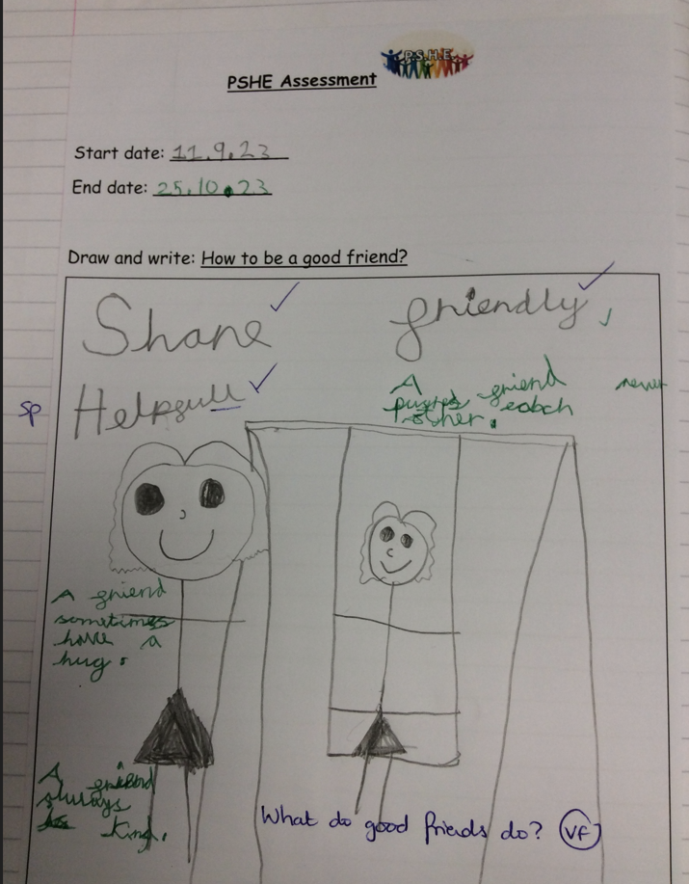 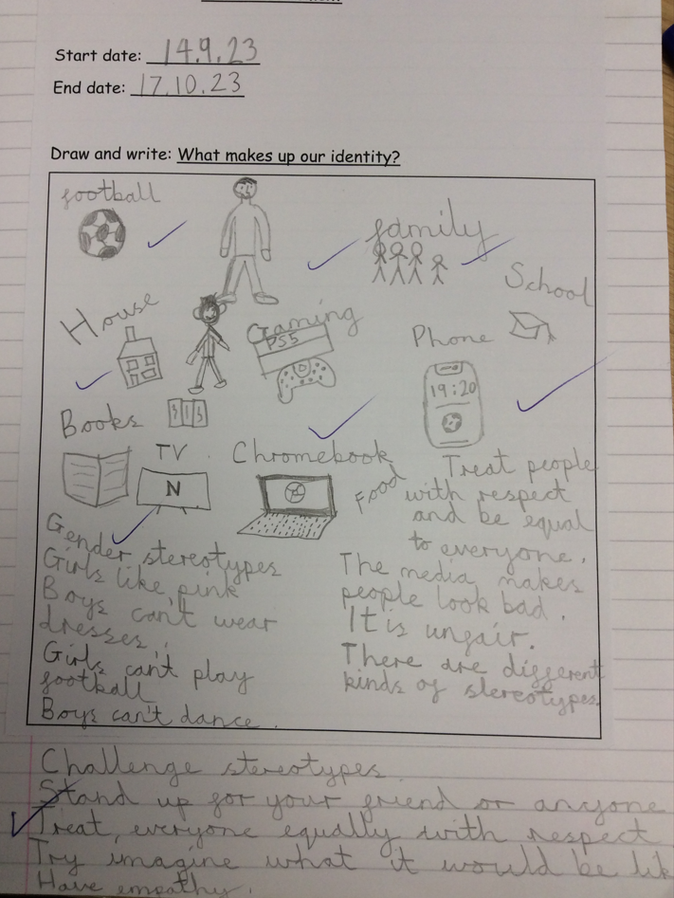

Impact will also be measured through:

- lesson observations

- book scrutiny

- staff voice

- data analysis

- pupil voice