**Relationships, Sex and Health Education (RSHE) Policy**

**Little London Primary Academy**

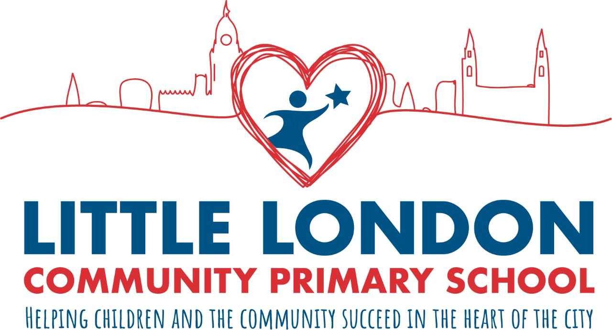

Policy written date: July 2023

Policy written by: Joanne Birch

Policy agreed by Governors: September 2023

Mid policy review: September 2024

Date of policy review: September 2025

At Little London, we strive for our children to be safe, confident, knowledgeable, strong and kind individuals, who are able to make good decisions about their futures and lifestyle choices. Our Relationships, Sex and Health Education (RSHE) curriculum is a key component in this. The school wants parents/carers and pupils to feel assured that RSHE will be delivered at a level appropriate to both the age and development of pupils, and safe to voice opinions and concerns relating to the RSHE provision.

1. Considerations in Writing the Policy:

When writing this policy, the voices and needs of our community were considered. We include all pupils regardless of their age, sex, race, disability, religion or belief, gender reassignment, or sexual orientation. All classes include pupils with different abilities and aptitudes, experiences, religious/cultural backgrounds, gender and sexual identities. To encourage pupils to participate in lessons, teachers will ensure content, approach and use of inclusive language reflects the diversity of the school community and helps each and every pupil to feel valued and included in the classroom.

Considerations will be made for:

● religious and cultural diversity

● differing gender needs and abilities, including SEND

● diverse sexuality of pupils

● pupil’s age and physical and emotional maturity

● pupils who are new to English Ethnicity, religion and cultural diversity

Our policy values the different backgrounds of all pupils in school and, in acknowledging and exploring different views and beliefs, seeks to promote respect and understanding. We encourage respect for all religions and cultures. We do not ask pupils to represent the views of a particular religious or cultural group to their peers, unless they choose to do so.

1. Why is RSHE needed?

* We are required to teach Relationships and Health Education as part of our Personal, Social, Health and Economic Wellbeing and Careers Education (PSHE) curriculum. Current regulations and guidance from the Department for Education (DfE) stated that in September 2020, all schools must deliver Relationships and Health Education (this was extended to Summer 2021 due to the covid-19 pandemic). High quality Relationships Education, Health Education and Sex Education help create a safe school community in which our pupils can grow, learn and develop positive, healthy behaviour for life.
* Now more than ever before, children are exposed to representations of sex and sexuality through the media/ social media and the social culture around them, so we need to present a balanced view of RSHE and help them to be discerning and stay safe. This is all part of our belief in the ‘prevent’ curriculum, which empowers and informs our young pupils with the knowledge in which they need to make the right choices for them and keep themselves and others safe.
* RSHE plays a vital part in meeting the school’s safeguarding obligations as outlined in the updated Keeping Children Safe in Education – Statutory guidance for schools and colleges (September 2023).
* Children have a right to good quality education, as set out in the United Nations Convention on the Rights of the Child.
* Children have the right to be prepared for the physical and emotional changes they undergo at puberty, and young people want to learn about relationships. Older pupils frequently say that Relationships and Sex Education was ‘too little, too late and too biological’. Ofsted reinforced this in their 2013 ‘Not Yet Good Enough Report.’
* Ofsted is clear that schools must be ‘developing pupils’ age-appropriate understanding of healthy relationships through appropriate relationship and sex education.’
* Schools maintain a statutory obligation under the Children Act (2004) to promote their pupils’ emotional wellbeing, and improve their ability to achieve in school and under the Education Act (1996) to prepare children for the challenges, opportunities and responsibilities of adult life. A comprehensive RSHE programme can have a positive impact on pupils’ health and wellbeing and their ability to achieve, and can play a crucial part in meeting these obligations.

1. Development process

This policy was produced by Joanne Birch [PSHE Lead and Assistant Principal]. From Spring 2021, the law requires primary schools to consult on their Relationships Education policy.

Parents and carers were consulted through making the policy accessible on the school website and alerting parents to this. Their needs thoughts, opinions and needs were taken on-board and amendments to the original RSHE policy were made. Parental feedback was shared. Teaching and non-teaching staff were consulted also.

Governors were consulted via email and within governor meetings. This policy has been amended and approved by the Headteacher (Acting Headteacher Carol Dunworth at the time) and Governing Body. It will be reviewed every 2 years, with a mid-point review after 1 year.

We are committed to the ongoing development of RSHE in our school. We will use the following indicators to monitor and evaluate progress:

● a coordinated and consistent approach to curriculum delivery has been adopted. Staff have and will continue to receive regular support and training. The curriculum intent is reviewed annually and key topics are closely monitored within half terms.

● the content of the RSHE curriculum is somewhat flexible and responsive to pupils’ differing needs e.g. through the use of pupil perception data such as the My Health My School Survey/Pupil wellbeing survey. We have what we call a ‘responsive curriculum’, whereby we address certain areas and add them in as additional topics or lessons in response to the needs of our children and community.

● children are receiving an entitlement curriculum for Relationships and Health Education in line with DfE national statutory guidance and local guidance. We will continue to update our RSHE with any developments made via the statutory guidance.

● there are clear learning objectives for all RSHE topics on the intent. Activities and pupils’ learning is assessed using both formative and summative approaches. Children do a ‘Draw and Write’ assessment as part of each lesson to enable staff to monitor good progress and address missed learning or misconceptions.

● opportunities for cross-curricular approaches are being used where appropriate, including in assemblies.

● policy and practice is revised regularly and involves staff, governors, parents/carers and pupils.

● when the more sensitive or non-statutory lessons to Relationships and Sex Education are being taught, parents and carers are informed and have the opportunity to voice opinion or opt out.

● a variety of methods are employed to communicate the key points of the policy and curriculum to the community e.g. through the school website and Class Dojo.

● additional provision is put in place to support our SEND pupils in RSHE related lessons.

● the subject leader will work and liaise with other PSHE leaders and successful, similar in-take schools, including those within the Gorse Academy Trust, in order to share and develop best practice.

1. Little London’s RSHE policy aims are to:

* Deliver an engaging and advanced curriculum that covers statutory requirements and meets the needs of all our pupils.
* Challenge intolerance, misconceptions, bias and stereotypes.
* Give students the chance to develop their own standards, morals and values.
* Make pupils feel comfortable and reassured with the changes and variations of change which their body may encounter through growth.
* Promote responsible behaviour and self-respect.
* Deter pupils from taking negative risks.
* Identify and support vulnerable pupils.
* Support pupils in understanding positive relationships and adulthood.
* Encourage pupils to ask questions, access advice, guidance and support and to openly discuss relationships and health in a supportive environment.
* Help pupils know how to make informed decisions in life.
* Understand the major role that positive mental health plays in having a successful life.
* Support pupils in developing an awareness and understanding of their own identity.
* Support and complement the role of parents and carers.

1. Implementation of RSHE:

* Each year group will take on a different PSHE theme each half term, so will cover 6 areas every year. Year 6 will instead go into more depth and have only 3 themes within their year, meaning they have each theme for a full term. Every child will be taught RSHE through our weekly PSHE lessons. These are around an hour long. There are the odd topics which will instead be taught as blocks, such as our ‘changes’ puberty topic in Y6. ‘The most effective model of delivery for PSHE is a sequenced, spiral programme that builds on prior learning as pupils progress through school’ with ‘regular curriculum time’ (PSHE Association). Cross curricular links are also made to our PSHE themes, such as the Fairtrade (equalities) geography topic within Year 4.
* RSHE themes will also be delivered through whole school or phase assemblies. These will be decided on by the Senior Leadership Team (SLT) and will be part of our ‘responsive curriculum’. We will teach pupils current topics within the media, news and community. Our assemblies will also include a strong emphasis on positive morals, responsibilities and values.
* Special days/weeks/months are used to enhance the PSHE curriculum, such as Anti-Bullying week, Black History Month and Endangered Species Day.
* School songs, including our Leeds one, Proud and It’s the Climb promote our values.
* Our very own School Council will meet regularly to discuss how they can promote positive change and will feedback to classes as well as take on the views of their peers.
* Our strong belief in respectful behaviour reflects our PSHE curriculum. All our staff support upholding this.
* As we continue to develop as a school, we aim to offer more workshops and send home more guidance for parents and carers to support them in how to teach topics, such as reproduction, online safety, positive image and puberty.
* Our agreed ‘Ground Rules’ with particular reference to PSHE lessons, are used and promoted throughout the whole of school. These are:

### 1. Talk about ‘someone I know’, don’t use names. Respect privacy.

### 2. Ask questions but not personal ones.

### 3. Be mindful of differences including culture, religion and opinions.

### 4. Comment on what is said, not who has said it.

### 5. Let people speak for themselves and do not interrupt.

### 6. Keep the conversation within the room.

### 7. Respect others.

### 8. It is ok to not join in or pass.

### 9. Listen.

### 10. Ask for help.

* Each class has an ‘Ask-it Basket’, which allows pupils to pop in questions, disclosures or statements, often with reference to our PSHE content. It is important that pupils feel able to ask any questions that they wish and that their questions are valued. While pupils’ questions will be answered as openly and honestly as possible, pupils’ prior learning and readiness must be considered when responding to their questions. Teachers in Little London feel able to ask a pupil to wait for an answer to a challenging question, giving them time to consult with the SLT, the safeguarding team, learning mentors and/or subject leads if they feel this is appropriate, or if the question raises potential safeguarding concerns. (For instance: ‘That is a really interesting question and I need time to think because I want to give you a proper answer.’) Teachers are able to work with colleagues, if necessary, to construct an appropriate answer. Pupils can also choose whether they would like their question answered in a whole class setting or if they would prefer a private conversation, by indicating on their piece of paper. Pupils are encouraged to write their name on the paper for safeguarding reasons, though teachers may not always acknowledge the author to the rest of the class.
* In certain lessons of the Year 4 and Year 6 puberty topics, children will work in single-gender groups. Our policy is sensitive to the needs of different groups. Working in single-gender groups can considerably ease concerns about RSHE, and help to ensure that pupils receive the RSHE to which they are entitled. Single-gender groups can also help boys and girls to feel safer and less embarrassed about airing issues and discussing relationships. Where single-gender groups are used for pupils, they will always be given time after the sessions to come together in a controlled environment to share and discuss what they have learnt, before leaving the classroom

1. Safeguarding and Child Protection

Through RSHE, we will teach pupils the knowledge they need to recognise and to report abuse, including emotional, physical and sexual abuse. This will be delivered by focusing on boundaries and privacy, ensuring young people understand that they have rights over their own bodies. This will also include understanding boundaries in friendships with peers, families and with others, in all contexts including consent, including online. Pupils will be taught how to report concerns and seek advice when they suspect or know that something is wrong. At all stages, it will be important to balance teaching children about making sensible decisions to stay safe (including online) whilst being clear it is never the fault of a child who is abused and why victim blaming is always wrong.

When teaching any sensitive issue, young people may give cause for concern. All adults are aware of our safeguarding arrangements and procedures. If the school has any reason to believe a pupil is at risk, safeguarding procedures that comply with our Safeguarding Policy will be followed.

Within our more sensitive topics and lessons, such as those on FGM or drugs and alcohol, we see it as best practice to have more than one adult present where possible.

1. Students with Special Educational Needs and Disability (SEND):

RSHE must be accessible for all students. This is particularly important when planning teaching for students who are vulnerable, at risk or SEND. For this reason, RSHE lessons should be personalised with these pupils in mind. Where necessary, SEND students or those that are vulnerable or at risk may be selected to partake in smaller workshops on topics.

1. Respectful Language

The use of respectful language which challenges sexism, homophobia and other forms of prejudice will be established in our PSHE lessons and RSHE content but will have benefits for the whole school community, both in and out of lessons. It helps to ensure we are a happy and healthy place to learn. Ofsted found that casual use of homophobic language in schools is often unchallenged (2013) – we always challenge it at Little London. The casual use of homophobic, biphobic and transphobic language in school will be challenged and pupils will be made aware that using the word ‘gay’ to mean something that is negative is wrong and unacceptable. To tackle this, staff might say, “You’ve used the word ‘gay’, but not in the right way.” As a result, pupils will hear references to, for example, ‘gay,’ ‘heterosexual’ and different kinds of relationships as part of teaching, such as when we talk about rights, respect or relationships. We believe it is crucial in helping children to abide by the law and to take no part in hate crime of any level. You can find, in Appendices 1 and 2, our glossary of terms to be used with pupils and a broader glossary for staff to support appropriate language and clarity of terms.

1. Consent

At Little London, we take every opportunity in all areas of our curriculum, to teach children about consent. Consent means agreeing to do something. Conversations and lessons about consent begin at an early age, exploring everyday boundaries within friendships and other relationships. Children are taught about digital consent, peer pressure and broader rights and responsibilities. As a school, we value a person’s right to autonomy and being in control of their own body. Children are signposted to people and places in which they can receive advice and support from regarding consent.

## MANDATORY RSE AND CONSENT

1. Curriculum Content:

Statutory aspects of Relationships Education covered at primary school:

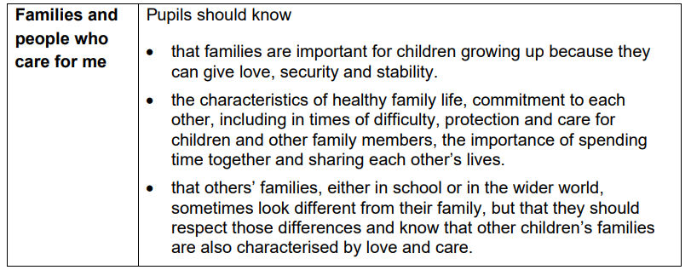

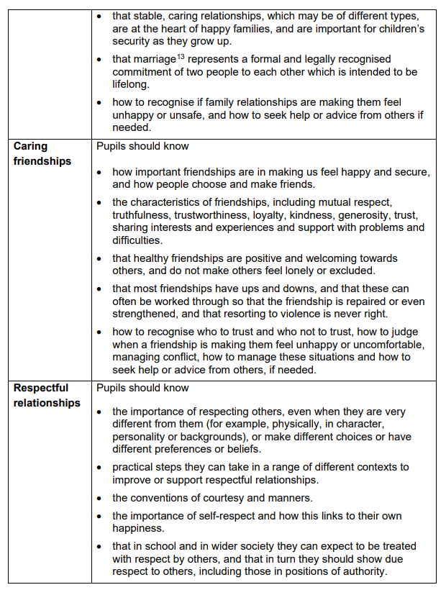

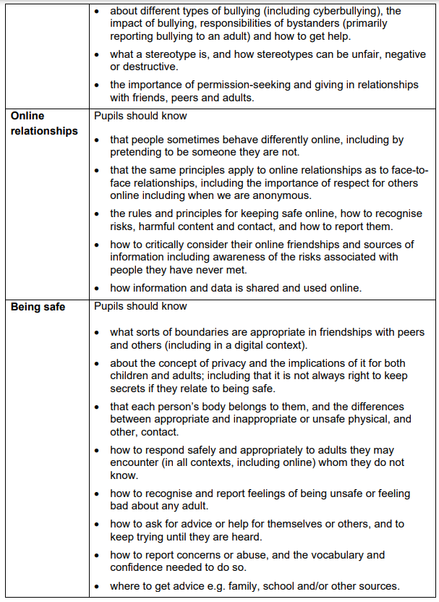

Statutory aspects of Health Education covered at primary school:

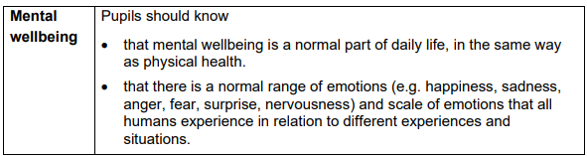

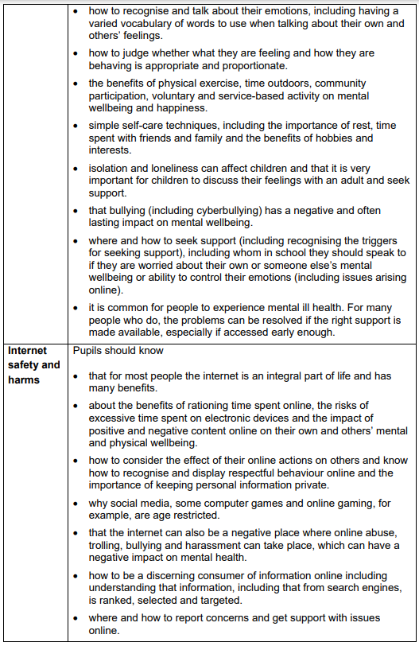

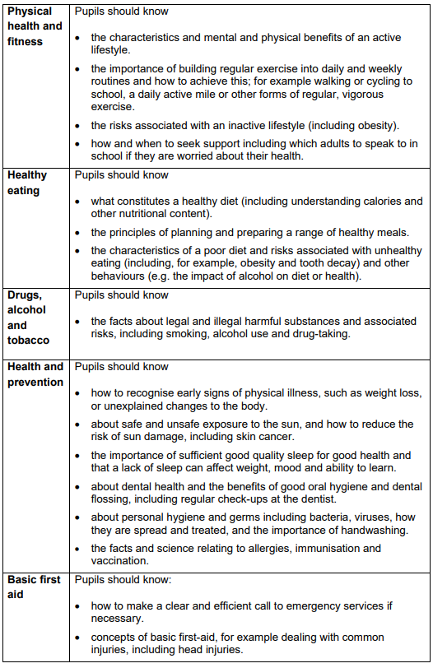

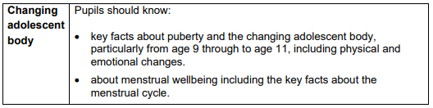

We use the PSHE Association to support our delivery of our RSHE and PSHE curriculum. They are ‘a [membership](https://pshe-association.org.uk/join-us?hsLang=en) association and charity, supporting a national network of 50,000 teachers and schools to teach’ PSHE well. They ‘offer guidance, training, teaching resources and advice.’ Their mission is ‘to raise the status, quality and impact of PSHE education so that all children and young people benefit.’ Their ‘[Subject Specialist](https://pshe-association.org.uk/meet-the-team?hsLang=en) team create all’ of their ‘resources, training and guidance.’

To read our full whole school overview of all of our half termly topics in each year group, along with the key aspects of PSHE that the pupils will learn, please refer to the subject skills taught in the EYFS (Appendices 3) and the PSHE subject handbook (Appendices 4).

Whilst FGM (Female Genital Mutilation) is a non-statutory element of the RSHE curriculum, schools have the prerogative to deliver aspects of non-statutory content which they deem has contextual safeguarding relevance and at Little London Academy we feel it does. Year 5 pupils will do one lesson on FGM strictly only using the accredited lesson plan from the National FGM Centre. To look more closely at this, please see the link within the final half term on the curriculum overview for Year 5.

1. Parents and Carers

Here at Little London we aim to work in partnership with parents and carers when delivering the right information and messages about relationships and health. Parents/carers have a right to withdraw their children from non-statutory aspects of RSHE lessons (see highlighted yellow sections in Appendices 4), but not from those elements of the science curriculum, nor do parents and carers have the right to withdraw their child from the statutory learning of RSHE.

Before granting any such request, it is recommended as ‘good practice’ (DfE) ‘for the Headteacher to discuss the request with parents and, as appropriate, with the child to ensure that their wishes are understood and to clarify the nature and purpose of the curriculum’. It is important at Little London that we take on board the wishes of the child, their opinion and voice, whilst also keeping their safety our number one priority. When considering what to allow learners to be withdrawn from, as part of our RSHE provision, the school will work within the Gillick Competency and Fraser Guidelines when taking into account the learner’s own wishes. The Gillick Competency and Fraser Guidelines are attached in Appendices 5.

School will document the process of speaking with parents to ensure a record is kept. The Headteacher is also likely to discuss with parents and carers that are wanting to withdraw their child from Sex Education lessons the benefits of receiving this important education and any detrimental effects of being excluded from this learning, including the child hearing their peer’s version of what was said in class rather than what was directly taught.

Little London staff will respect the wishes of all parents and carers and will always be available to openly and calmly discuss the content of our RSHE. ‘If a pupil is excused from sex education, it is the school’s responsibility to ensure that the pupil receives appropriate, purposeful education during the period of withdrawal. There is no right to withdraw from Relationships Education or Health Education’ (DfE).

1. Working with Outside Agencies and Visitors

Where appropriate, we may use visitors from external agencies or members of the community to support RSHE. Working with external organisations enhances delivery of RSHE, bringing in specialist knowledge, which gives different ways of engaging with our pupils. When using visitors, the school’s policy on use of visitors will be used. A teacher will be present throughout these lessons.

Visitors will be given a copy of this policy, and any other relevant policies, and expected to comply with the guidelines outlined within it. Our partnership with the local community is also a priority, and we recognise and value its contribution to the RSHE programme.

We will ensure that the teaching delivered by the visitor fits with our planned programme and policy. We will discuss the details of how the visitor will deliver their sessions and ensure that the content is age-appropriate and accessible for our pupils. We will ask to see the materials visitors will use as well as a lesson plan in advance, so that we can ensure it meets the full range of pupils’ needs.

We will agree in advance of the session how confidentiality will work in any lesson and how a safeguarding report should be dealt with by the external visitor. It is also important that children understand how confidentiality will be handled in a lesson and what might happen if they choose to make a report. Use of visitors will be to enhance teaching by an appropriate member of the teaching staff, rather than as a replacement for teaching by those staff.

1. Documentation relating to this policy:

Below is a list of the documents that helped inform Little London Primary Academy’s RSHE Policy:

● Education Act (1996)

● Equality Act (2010)

● Children and Social Work Act (2017)

● DfE: Relationships Education, Relationships and Sex Education (RSE) and Health Education: Statutory guidance for governing bodies, proprietors, head teachers, principals, senior leadership teams, teachers (2019)

● Keeping Children Safe in Education (2023)

● United Nations Convention on the Rights of the Child

● The Gorse Academies Trust RSHE Policy.

13. Further Information for Parents and Carers:

